**Software Requirements**

**Document**

**Senior Project – Name TBD**

**09/14/2022**

**V 1.0**

**Emily Sear**

|  |
| --- |
| **Revisions** |

| Version | Primary Author(s) | Description of Version | Date Completed |
| --- | --- | --- | --- |
| 1.0 | Emily Sear | Creation of document & explaining of requirements | 9/14/2022 |

|  |
| --- |
| **Review & Approval** |

Requirements Document Approval History

| Approving Party | Version Approved | Signature | Date |
| --- | --- | --- | --- |
|  |  |  |  |
|  |  |  |  |

Requirements Document Review History

| Reviewer | Version Reviewed | Signature | Date |
| --- | --- | --- | --- |
|  |  |  |  |
|  |  |  |  |
|  |  |  |  |

|  |
| --- |
| **Table of Contents** |

1. Introduction 3

1.1 Purpose 3

1.2 Document Conventions…………………………………………………………………….3

1.3 Intended Audience…………………………………………………………………………3

1.4 Scope……………………………………………………………………………………….3

1.5 References………………………………………………………………………………….3

2. General Description 3

2.1 Product Perspective………………………………………………………………………...3

2.2 Product Features 3

2.3 User Class Characteristics 3

2.4 Operating Environment 3

2.5 Constraints 3

2.6 Assumptions and Dependencies 3

3. System Requirements 3

4. External Interface Requirements 4

4.1 User Interfaces 4

4.2 Hardware Interfaces 4

4.3 Communications Interfaces 4

4.4 Software Interfaces 4

5. Non Functional Requirements 4

1. Introduction

* 1. **Purpose:**

The goal of this project is to solve the problem of having no central place for a person to easily track all of their symptoms digitally. Along with this, this project hopes to help track data of the user and provide an easy format for the user to share this data with medical professionals. This project will not provide any medical diagnostics but rather a platform that allows better communication and informed decisions to be made from the data being shown.

* 1. **Document conventions:**

Healthcare professionals – these are people that will be provided with the data that is tracked through this application.

Person experiencing symptom – this is the person who is tracking their data, the person experiencing the symptom could also have a caregiver tracking their symptoms for them.

* 1. **Scope:**

This software will help align with business and personal goals of helping out both the creator and others within the creator’s community. Overall, this software is being built with the intention of helping others have more ease within their lives.

## 2. General Description

**2.1 Product perspective:**

The product that is being created is a mobile application, being designed for both IOS and Android devices. This mobile application will feature a daily log that the user would be able to thoroughly track their daily symptoms within. In addition to the daily logs, this application will create a report that will allow users to print out daily logs in order to give their doctors information about their daily symptoms. These reports will not focus on any sort of diagnoses but rather point out specific symptoms that are recorded a lot or recorded at specific periods of times.

**2.2 Product features:**

The user will have to sign into the application with an account, this will start with a simple email address and password that the user will enter. This will create a user profile that the user will be able to edit the data from.

User Profile:

* Personal Details: First Name, Last Name, Email Address
* Medical Details: Diagnoses, Medications (Name, dosage, date started on, ordering doctor)

The daily log will feature many flows/screens that the user will be able to go through. This log will begin with a flow that is designed to be a quick overview of the day of the user, at the end of this overview, the user will be able to continue into a more detailed questionnaire or to complete the flow.

Daily Log:

* Overview:
  + Overall Scale
  + Pain Scale
  + Mood Scale
  + Fatigue Scale
  + Symptoms: Name, scale of severeness, timeframe, was the user able to continue on with daily life, tag with what condition(?)
  + Medications Taken & at what times (or rough times)
  + Avg heart rate
  + On period?
* In-Depth
  + Diagram of drawing – click on area to give details
    - Type of symptom (able to pick from list given beforehand or provide a new one)
    - Scale of severeness
    - Notes
  + Mental Health
    - Show overall mood from overview
    - In depth symptom logging (that was not logged beforehand)
    - Mental Health questionnaire

The last part of this application will provide an option for the user to generate a report over a specified period of time to present to healthcare professionals. This report will include all the data from the daily logs, as well an ‘overview’ section to provide a quick way to see common symptoms. This will include charts of all of the general scales (overall, pain, mood, fatigue) and any other common themes that the application is able to find through the data that it is given.

* 1. **User class and characteristics:**

People Experiencing symptoms:

These users will be the ones who are actually experiencing symptoms and are entering the data on their own. This user group will likely include people who are experiencing chronic conditions that need close monitoring. This group would also include people who are experiencing symptoms, but currently do not have enough data to obtain a diagnosis.

For both of the users in this group, this app will provide a central hub and communication tool for these users to track their conditions. It may provide the doctors with the necessary tools in order to make diagnoses or to change medications.

Caregivers:

This user group will include those who are caregivers, partners, or close to the person experiencing the symptoms. They will answer the questions for the person experiencing the symptoms and will act as a means for the person experiencing the symptoms to be able to provide accurate data to the healthcare professional.

* 1. **Operating environment:**

The software will be developed with Visual Studio using C++ as the base for both the IOS and Android applications. The database for accounts will be an Oracle cloud relational database and the database for logged information will be an Oracle cloud nonrelational database.

* 1. **Constraints:**

This project will be completed with at least 300 hours a week over the course of August – December 2022. The biggest constraint will be the stress level of Emily.

* 1. **Assumptions and dependencies:**

An assumption about the user is that they are already familiar with their conditions and that they are familiar with some form of technology. Another assumption is the bias that the creator has about her own disabilities. This will likely lead to the production of flows that the creator would first use herself.

## 3. System Requirements

Note: this section will be updated throughout the implementation of this project

**3.1 General Functional Requirements**

**3.1.1. All data provided to the application should be stored in either of the Oracle cloud databases.**

1. Data shall only be stored on the Oracle databases provided for this project.
2. All data should have complete fields where necessary
3. Data should be encrypted when stored, the security of the data is upmost priority for this application.
4. Data should only be accessed when necessary for functions within the application.
5. Limited network / wi-fi availably or if the Oracle system is down could provide a technical challenge.
6. All other aspects of this application are based on this requirement.

**3.1.2. The data should be accessible through queries, to only authorized users.**

1. Only users that are authorized to access a specific row in a database should be able to access that data.
2. Only the creator should be able to access all data, and only should be able to access this data in its encrypted form.
3. Users should be able to access their data through forms on the application or through the report.
4. The data should never be difficult to access to the user that is authenticated to access that data.

**3.1.3. The data should be inputted through forms that the user fills out.**

1. The data should only be input through a specific user from forms that they fill out, these forms are labeled as ‘daily logs’.
2. The user should be able to edit this data but should have to verify that their data is being overwritten.

**3.2 User Profile Functional Requirements**

**3.2.1 The user will verify that all information they inputted in their profile is correct before the account is created**

**3.2.2 The user profile will be divided into two sections: personal details and medical details.**

**3.2.3 When submitted, the user profile will submit the data to the database and an account will be created with the given email and password.**

**3.3 Daily Log – Overview - Functional Requirements**

**3.3.1 The overall scale, pain scale, mood scale, and fatigue scale will be stored as a number between 1 – 10 within the database.**

**3.3.2 The symptoms given will be stored as a list of other lists of symptoms within the database.**

**3.3.3 The medications taken will be related back to the medication table and a time/date will be added to this list**

**3.3.4 The height will be inputted in height and inches and stored as such in the database.**

**3.3.5 The weight will be inputted in pounds and stored in pounds in the database.**

**3.3.6 Average heart rate will be inputted as beats per minute (bpm) and will be stored as such in the database.**

**3.3.7 If user answers yes to the on-period question, it will flag a Boolean in the database as true.**

**3.4 Daily Log – In-Depth – Functional Requirements**

**3.4.1 The diagram of the drawing will include areas for the user to fill it, it will then label these areas with the symptoms, type of severeness and any notes.**

**3.4.2 In depth of logging will allow user to add notes to symptoms indicated in the daily log or to be able to add new symptoms.**

**3.4.3 The mental health section will ask mental health specific questions about symptoms and will show the user the mood indicated beforehand to prompt them about any symptoms related to mental health.**

**3.5 Report – Functional Requirements**

**3.5.1 The report will include all the data from the user that was given.**

**3.5.2 The overview section of the report will show graphs of the overall scale, pain scale, mood scale, and fatigue scale over the chosen period of time.**

**3.5.3 The overview section will pick out key words that were found within the daily logs and print out these keywords on the overview section.**

**3.5.4 The overview section will show the top ten symptoms reported over the chosen period of time.**

1. This section will show an average of the severeness of the symptoms.
2. This section will show the highest and lowest severeness reported.

## 4. External Interface Requirements

4.1 User Interfaces

Login Screen ([link](https://www.figma.com/file/5CEi6DLjqsXbSi7e6HTMOg/Account-Creation-%26-Login-Screens?node-id=4%3A12))  
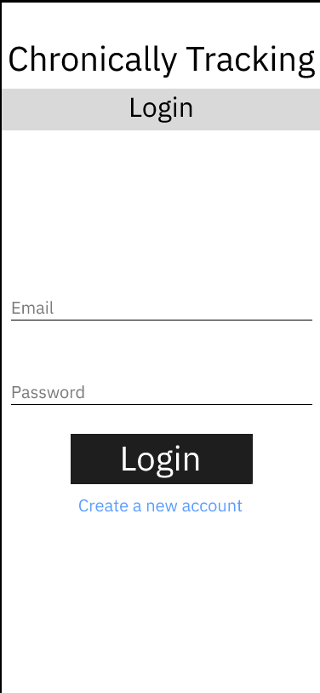

Sign Up Screens ([link](https://www.figma.com/proto/5CEi6DLjqsXbSi7e6HTMOg/Account-Creation-%26-Login-Screens?node-id=19%3A112&scaling=min-zoom&page-id=15%3A4))

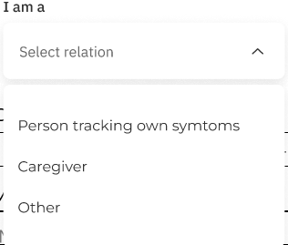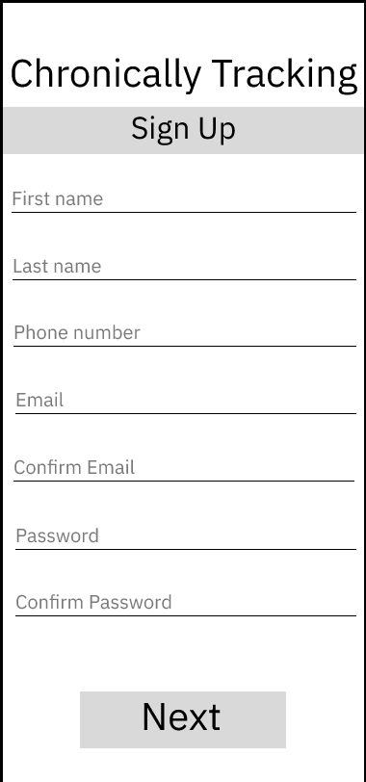 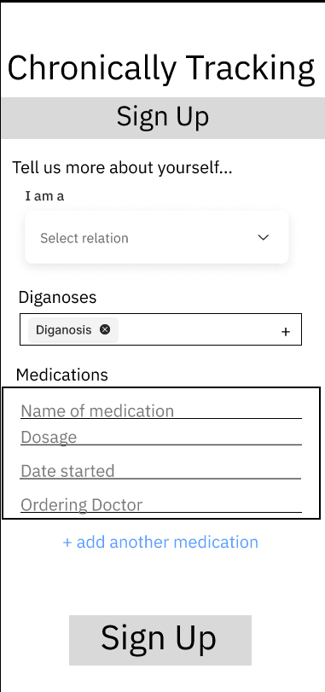

Daily Log – Overview ([link](https://www.figma.com/proto/W01BBHkhgpsqEAIJyjye8f/Daily-Log?node-id=13%3A15&scaling=scale-down&page-id=0%3A1))

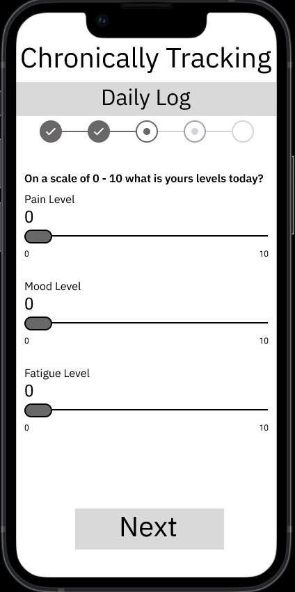 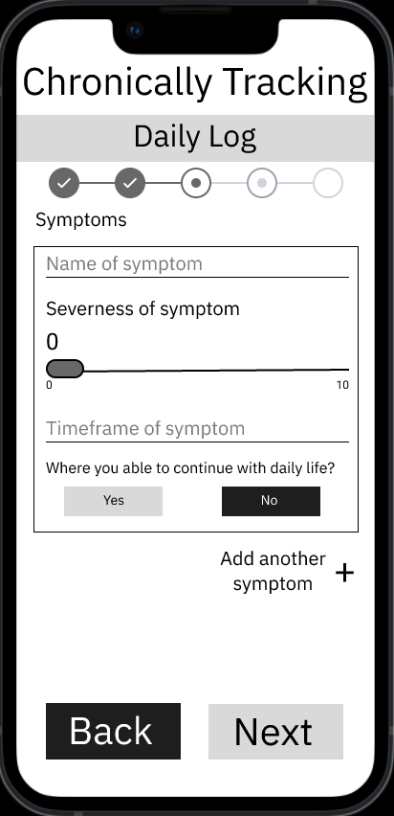 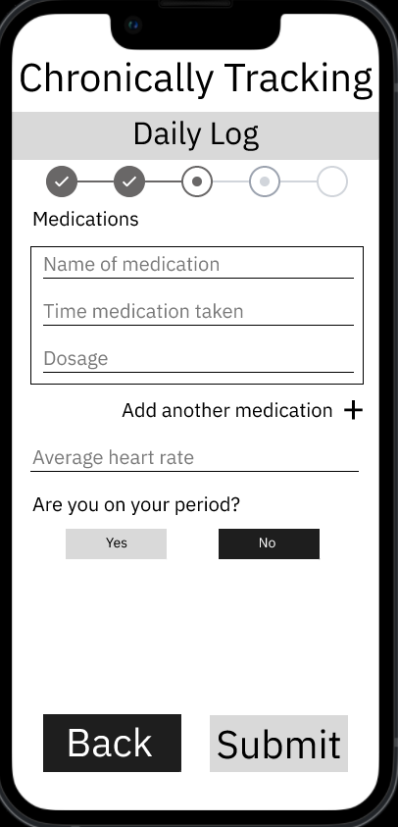

Daily Log – In-depth ([link](https://www.figma.com/proto/W01BBHkhgpsqEAIJyjye8f/Daily-Log?node-id=31%3A247&scaling=min-zoom&page-id=31%3A14))

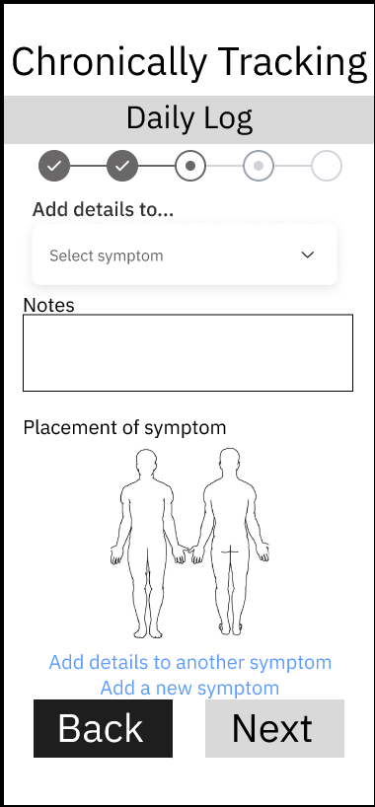 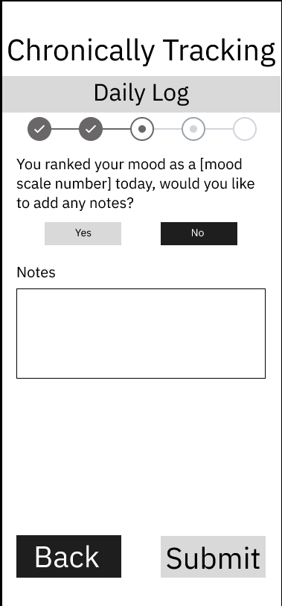

Home Screen

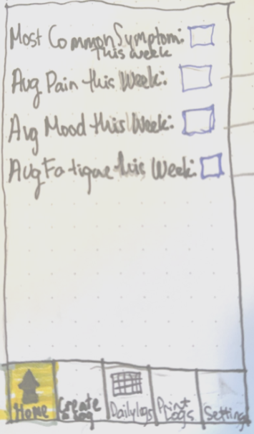 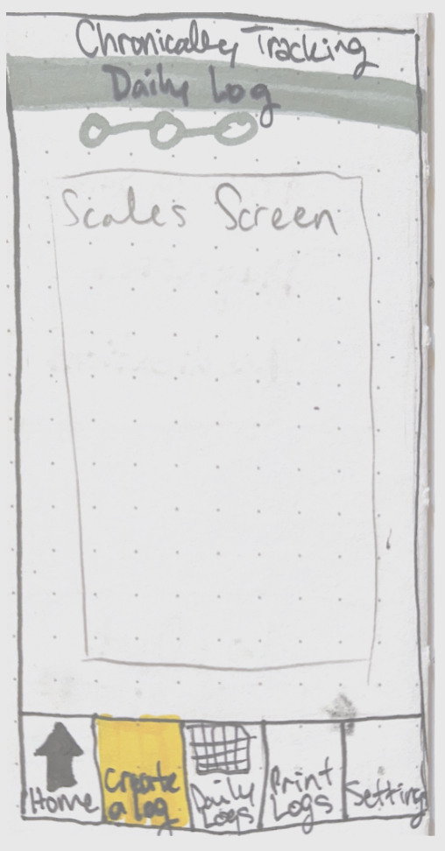 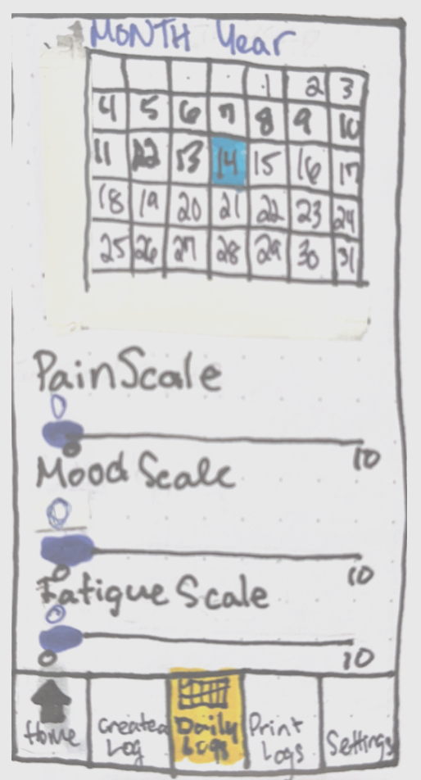 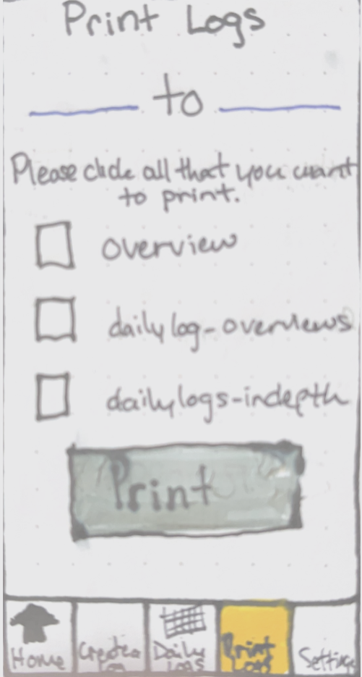

4.2 Hardware Interfaces

This application will be able to run on all currently supported Android and IOS devices.

4.4 Software Interfaces

The backend software will be written with C++ in visual studio. The android frontend software will be built with visual studio. The relational database will be built with SQL and communicated with such. The nonrelational database will be built with json and communicated with such.

## 5. Non-Functional Requirements

**5.1 Safety requirements**

This application will clearly state that it is not intended for any diagnoses of problems, but rather it is intended to help communication with healthcare professionals. Along with that, any user will be able to turn off features like logging their height and weight. This will allow users to use this application to help them rather than to harm them more.

**5.2 Security requirements**

Privacy and data protection are the upmost important for this project. All data will be encrypted and only accessed when absolutely necessary throughout the project. Data will never be shared with third parties and will be kept as secure as possible within the application.

**5.3 Reliability Requirements**

Reliability is a key attribute of this application. With this, the user’s data will be regularly backed up to have minimal data loss in the case of unforeseen circumstances. The system will be thoroughly tested to ensure reliability before deployed.

**5.4 Future Updates**

Any future updates should be thoroughly documented, and all corresponding documents should be updated before any updates be made to the code base.